[Date] CONTACT:
[Admin. name], Administrator
[Phone number]
[Email address]

PHOTO AND CUTLINE

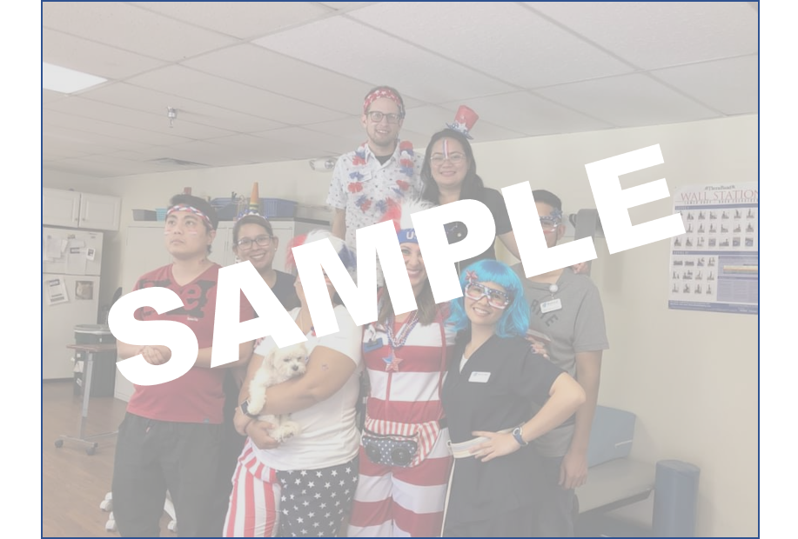

[Community name] residents, patients and employees celebrated National Mad Hatter Day by [Include highlights here].

Participants listed left to right are [List participants’ first and last names].

[Community Name] provides quality healthcare for up to [Number] patients and residents including those needing skilled nursing and rehabilitative care. [Community Name] has been part of the [City] community since [Year]. For more information about [Community Name], call [Phone number] or visit www.[WEBSITE].com.

# # #

