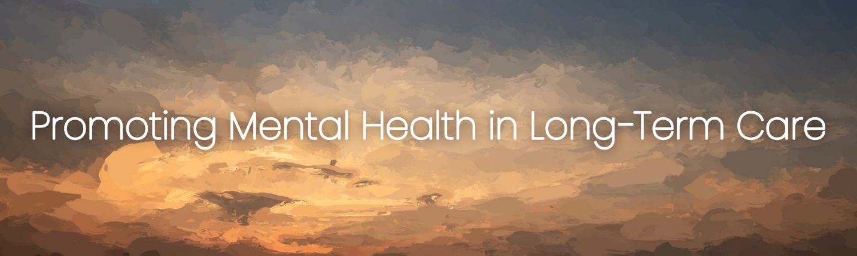

**Promoting Mental Health in Long-Term Care**

The month of January hosts National Popcorn Day and National Compliment Day among other lighthearted celebrations; however, it is also known to be Mental Wellness month. Before this month comes to an end, let’s take some time to discuss the importance of mental health awareness in long-term care and evaluate current efforts in place to promote mental wellness.

According to a study published by the National Institutes of Health, 65-90% of nursing home residents are affected by a mental health disorder. Furthermore, research tells us that decreased mental health can affect both cognitive and physical functioning, and ultimately, a resident’s quality of life. With this knowledge, it’s not surprising that the Centers for Medicare and Medicaid Services (CMS) recently updated requirements and compliance processes related to mental health services in the long-term care setting. Awareness of the effects of mental health on residents is imperative, but only one piece of the puzzle in the greater picture of optimized mental wellness. Focus on facility processes that facilitate opportunities for residents to feel like their best selves is a key component to success.

Listed below are some practical ways for skilled nursing facilities to promote mental wellness among residents:

* Maintain connection with friends and family. Provide accessibility to necessary devices for planning and interaction.
* Increase opportunities for decision-making. Offer choices in meal options, leisure activities, and daily routine.
* Provide activities to promote physical and mental exercise. Encourage residents to safely participate in memory games, puzzles, and home exercise programs.
* Encourage social interaction through group activities. Ensure every resident is invited to attend celebrations, group activities, and/or community outings.
* Implement resident-specific interests in daily life. Promote facility staff awareness of each resident’s motivation and activities of interest.

Reliant strives to serve with you to promote the mental health of residents in your facility. Reach out to your Reliant partners to learn more.