Materials:
- Mixing bowl (microwave safe)
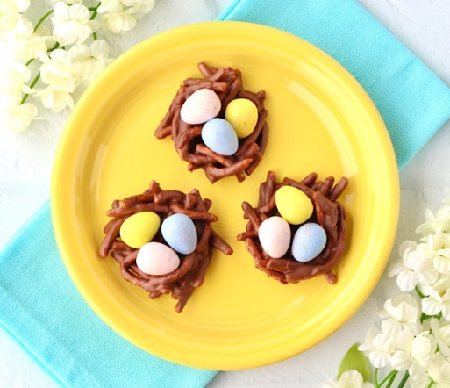
- Mixing spoon
- Measuring cups
- Microwave
- Baking sheet
- Parchment paper
- 3 cups crunchy chow mein noodles
- Cadbury mini eggs
- 1 bag milk chocolate chips
- Creamy peanut butter
Directions:
- Gather your ingredients.
- Prepare a baking sheet with parchment paper, set aside.
- Add 1 bag of chocolate chips and 1/3 cup of peanut butter to microwave safe mixing bowl.
- Microwave for 45 seconds, stir well, and then microwave for 25 additional seconds.
- Add chow mein noodles to chocolate/peanut butter and gently stir until all noodles have been coated.
- Use a spoon to scoop up portions of noodles and transfer to parchment paper.
- Shape into a bird’s nest and press down on the top to give it a bit of an indent.
- Place 3 chocolate eggs on top of each nest.
- Chill bird’s nests in the refrigerator for 2 hours.
- Enjoy your tasty bird’s nests!

