**Materials:**

* Empty toilet paper rolls
* 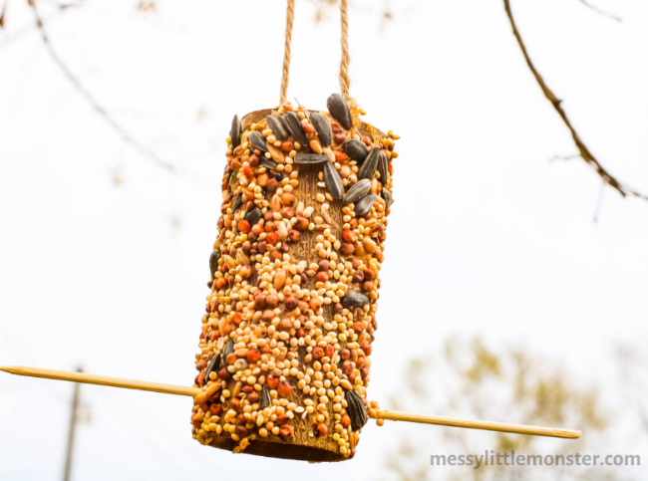Peanut butter
* Bird seed
* String
* Scissors
* Bamboo skewer
* Butterknife

**Directions:**

1. Gather your materials.
2. Prepare the bird seed by adding to a tray that is larger than the toilet paper rolls.
3. Use scissors to create a small set of holes at the top of the toilet roll tube.
4. Thread the string through the two holes and tie it in place.
5. Use scissors to create another small set of holes towards the bottom of the toilet roll tube.
6. Push the bamboo skewer through to make a resting perch.
7. Using the butterknife, spread a thin layer of peanut butter over the cardboard tube.
8. Immediately after applying the peanut butter, roll the tube in bird seed.
9. Press bird seed in any open spots.
10. Hang your peanut butter bird feeder up outdoors.
11. Wait for the birds to come!